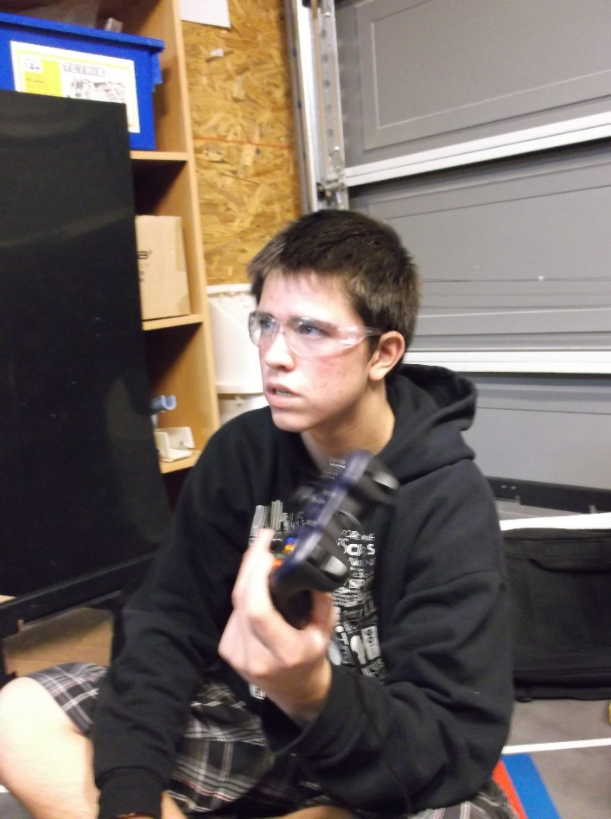
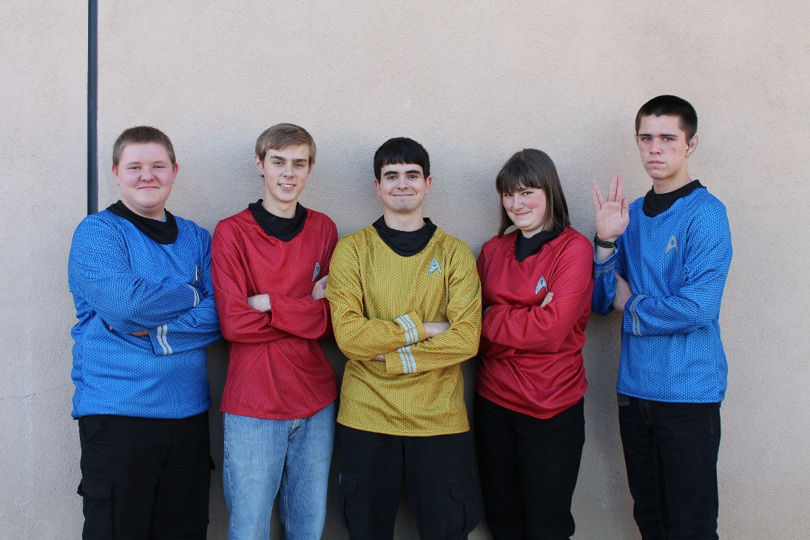
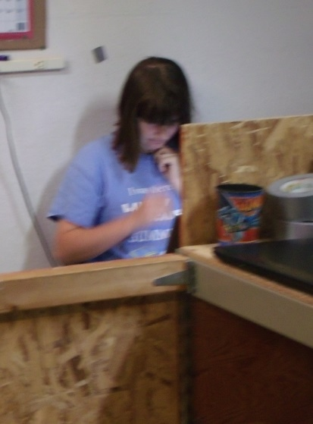
TEAM ORGANIZATION:

TEAM ORGANIZATION

PHI Omega and PHI Alpha:
PHI Robotics actually isn’t registered as one team- it’s registered as two. However, even though PHI Omega and PHI Alpha compete as separate teams, build two different robots, and consist of different team members, they come together to form the organization PHI Robotics. Although the teams often seem very different, PHI as a whole operates more as one team than two. Members of both teams share ideas, prototypes, and help each other whenever help is needed.
PHI Alpha and PHI Omega also share funds and parts. They fundraise together, and also joint-hosted the 2014 High Desert Qualifying Tournament. All in all, even though the teams can look very different from the outside, they really come together to make up a larger team- PHI Robotics.
In the beginning of the year, PHI Robotics begins as one team, but as prototypes are developed and integrated onto basic chassis, the teams begin to form naturally. After a few months of working with this, PHI has usually divided naturally into PHI Alpha and PHI Omega. These teams don’t always change much from year to year, however, with the exception of new members joining the team and senior members’ graduation. Jonathan, Jacob, Mike, Eddie, and Kaitlin were all members of PHI Omega during the 2012-2013 season and some of the older members were even part of Omega the previous year.

PHI Omega’s Organization:
PHI Omega also has its own team structure. As the most senior member, Jonathan leads the team over all, as well as taking leadership in the hardware area. This year he is mentoring three new members- Anna, Hanna, and Sergei- in hardware. Eddie also helps with hardware, though he is also a member of the software team.
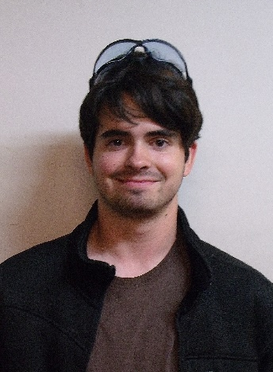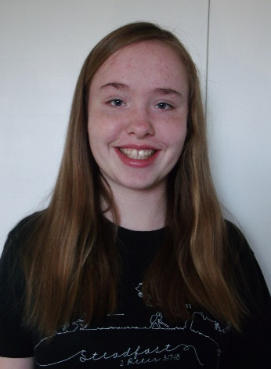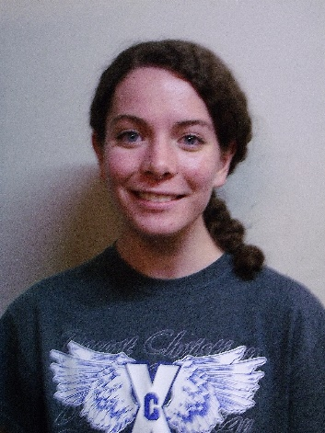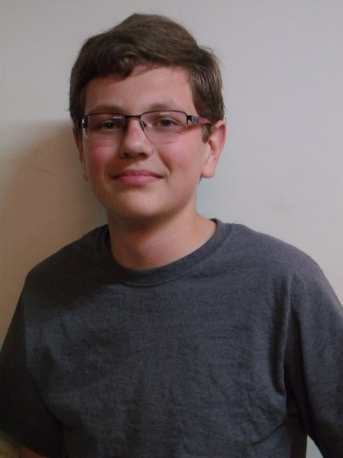
The hardware team

Noah, Eddie, and Becky make up the software team and are responsible for programming the robot. Noah is the software captain and does much of the major programming, and Becky is learning software from him and Eddie.
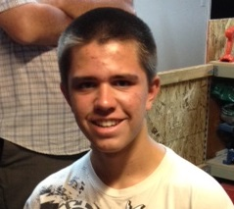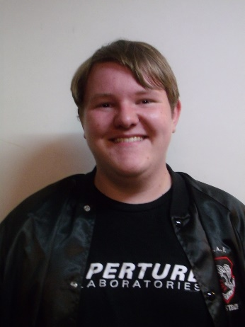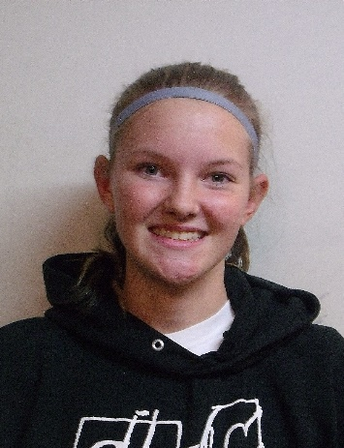
The software team
Kaitlin and Holly coordinate the Engineering Notebook. However, even though they coordinate the notebook, the rest of the team works primarily on their respective sections- the hardware team handles the hardware section, the software team the software section, and so on. All members work on the meeting log, as well as adding to the outreach section and other general sections.

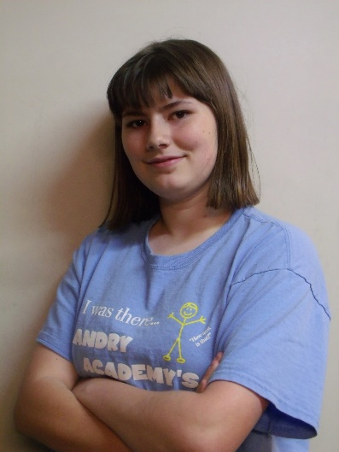
The notebook team

The Mentors:
Of course, no team would be complete without their mentors. Although PHI works primarily on its own, its mentors offer feedback on their designs, keep the teams focused, and help them plan and manage their time wisely. By helping us learn these skills, they help prepare us for life.

The Stinsons have been running PHI for seven years as an FTC team, and for even longer since PHI was first a VEX robotics team. Over the years they have generously opened up their house to us, first allowing PHI to work in an upper room and then, as the team expanded, giving the team their entire garage. Even after Dylan graduated from robotics, they continue to host the team and keep it running. They also have given much time and effort to helping prepare for the High Desert Qualifying Tournament in the two years it has run (2013 and 2014). PHI is greatly blessed to have such amazing mentors.
Dylan himself is a graduated PHI mentor and a computer genious. It has been said that all Dylan has to do is walk into a room and immediately all the electronics begin to work. At the High Desert Qualifying Tournament which PHI hosted, Dylan kept the software running as smoothly as possible. Now he helps guide our software team in the right direction when they get stuck on a tough coding problem. When he’s not offering advice on software or doing college work, Dylan designs drills to help keep the team in peak driving condition.
Mr. Pierce and Mr. Cox are new mentors to PHI as of the 2014-2015 season. But although this is their first year mentoring, both have experience with PHI from their childrens’ time on the team.

